Attention 3rd Graders
Come join the MBES Biography Book Club!
Just read 10 biographies and complete this form, both sides, and return it to the Media Center by May 4th. We’ll have a celebration during the week of May 11th for everyone who returns the completed form by May 4th. Go to http://www.mbesmediacenter.com/programs.html for more information.
Title | Author
1
2
3
4
5
6
7
8
9
10

Please have your parents sign this form when it is complete. Don’t forget to fill out the other side of the form.
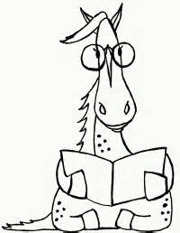
Parent/Guardian__________________________________________________
Student Name __________________________________________________
Teacher_________________________________________________________
Date ______________________________________________________________

Choose your 4 favorite Biographies from the other side of this sheet and answer these questions about the book
Title of Book #1 _____________________________________________________
Who is this book about?______________________________________________
What did you learn about this person by reading the biography? Just choose some facts that you found interesting. _______________________________________________________________________________________________________________________________________________________________________________________________________________________________________
Title of Book #2 _____________________________________________________
Who is this book about?______________________________________________
What did you learn about this person by reading the biography? Just choose some facts that you found interesting.
_______________________________________________________________________________________________________________________________________________________________________________________________________________________________________
Title of Book #3 _____________________________________________________
Who is this book about?______________________________________________
What did you learn about this person by reading the biography? Just choose some facts that you found interesting.
______________________________________________________________________________________________________________________________________
Title of Book #4 _____________________________________________________
Who is this book about?______________________________________________
What did you learn about this person by reading the biography? Just choose some facts that you found interesting.
_______________________________________________________________________________________________________________________________________________________________________________________________________________________________________

