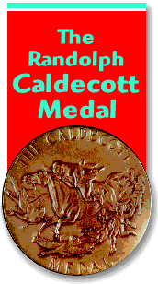
Name_____________________Teacher _________________
Caldecott Book Club
For Kindergarten and 1st Grade Students and Parents
Reading these books aloud is permitted and encouraged!

Just read 20 Caldecott Medal or Honor Books and return this form to the media center. For rules and a list of Caldecott Medal and Honor Books go to http://www.mbesmediacenter.com/programs.html .
The Deadline to return forms is May 4th.
1 | 11
2 | 12
3 | 13
4 | 14
5 | 15
6 | 16
7 | 17
8 | 18
9 | 19
10 | 20
Parent/Guardian Signature | Date Completed

