Fourth Grade
American Revolution
SS4H1 Explain the causes, events, and results of the American Revolution.
a. Trace the events that shaped the revolutionary movement in America: French and Indian War, 1765 Stamp Act, the slogan “no taxation without representation,” the activities of the Sons of Liberty, the activities of the Daughters of Liberty, Boston Massacre, and the Boston Tea Party.
Entry Event: Smartie Tax
Each student will select a piece of paper to determine whether they are a colonist, King/Queen, parliament, or tax collector.
The king and queen will read aloud each tax, and the collectors will have to collect the Smarties. At the end of the lesson, the colonist can keep the leftovers, and the King and Queen will get 75% of the collected Smarties, and Parliament will get 25%.

Second Grade
Native Americans
SS2G2 Describe the cultural and geographic systems associated with the historical figures in SS2H1 and Georgia’s Creek and Cherokee in SS2H2.
a. Identify specific locations significant to the life and times of each historic figure, and the Creek and Cherokee, on a political or physical map.
b. Describe how each historic figure and the Creek and Cherokee adapted to and were influenced by their environments.
c. Describe how the region in which these historic figures lived affected their lives and compare these regions to the region in which students live.
d. Describe the regions in Georgia
Entry Event: Who came before us?
In an outdoor space around the school, the teacher should bury different artifacts that relate the Cherokee and Creek tribes. Some examples include leather straps, arrowheads, moccasins, feathers, pottery, mud bricks, logs.

The students will dig through the garden to get a sense of who came before us in the area. Students can then sort the items into two different categories.

Kindergarten
Living vs. Nonliving

SKL1. Obtain, evaluate, and communicate information about how organisms (alive and not alive) and non-living objects are grouped.
a. Construct an explanation based on observations to recognize the differences between organisms and nonliving objects.
b. Develop a model to represent how a set of organisms and nonliving objects are sorted into groups based on their attributes.

Entry Event:
Give groups of students color copies of the images below and have them sort them into two piles. Students will have to determine the "rule" they are using for their sort. Discuss how the different groups sorted the pictures - identify any groups who sorted into living and nonliving things. If this was not done, direct the class to sort into living and nonliving things.

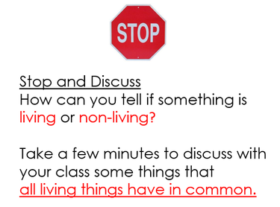
Create a class chart to define living and nonliving using the pictures.

See full lesson plan at

http://www.kindergartenkindergarten.com/2012/03/a-science-mini-unit-living-and-non-living.html

First Grade
Magnets

S1P2. Obtain, evaluate, and communicate information to demonstrate the effects of magnets on other magnets and other objects.
a. Construct an explanation of how magnets are used in everyday life. (Clarification statement: Everyday life uses could include refrigerator magnets, toys, magnetic latches, and name tags.)
b. Plan and carry out an investigation to demonstrate how magnets attract and repel each other and the effect of magnets on common objects.

Entry Event - Iron Filing Art:
Students will be given a set of magnets - different shapes, sizes, and strength - as well as a baggie with iron filings in it. Students will use the various magnets to create an iron filing masterpiece. Students cannot move the baggie or the contents with anything other than the magnets. Students will explore how shape and size may or may not be related to the strength of the magnet.

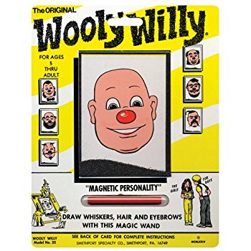

Second Grade
Shadows

S2E2. Obtain, evaluate, and communicate information to develop an understanding of the patterns of the sun and the moon and the sun’s effect on Earth.
a. Plan and carry out an investigation to determine the effect of the position of the sun in relation to a fixed object on Earth at various times of the day.
b. Design and build a structure that demonstrates how shadows change throughout the day.

Entry Event – Water Lilies Virtual Tour
Did you know that Monet created the Water Lillies with the same idea that we will use to create our project? He shows the same image at different times through the day. Click the image below to take a virtual tour of the museum where his art can be found. Look at how the colors and the shadows change from morning to afternoon to evening.

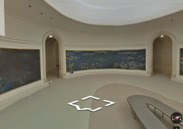

Entry Event – Shadow Tracing
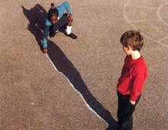
Students will use 4 different colors of chalk and work with a partner. At 8:00, students will find a place on the blacktop the shows their shadow. Students will trace their feet (so they can come back to the exact position) and their shadow and label the time. They will repeat the task at 10:00, 12:00, and 2:00.

Second Grade
Force and Motion

S2P2. Obtain, evaluate, and communicate information to explain the effect of a force (a push or a pull) in the movement of an object (changes in speed and direction).
a. Plan and carry out an investigation to demonstrate how pushing and pulling on an object affects the motion of the object.
b. Design a device to change the speed or direction of an object.
c. Record and analyze data to decide if a design solution works as intended to change the speed or direction of an object with a force (a push or a pull).

Entry Event – Push and Pull
Students will design and build a contraption to be used with Sphero or Dash the will push or pull an object a given distance.

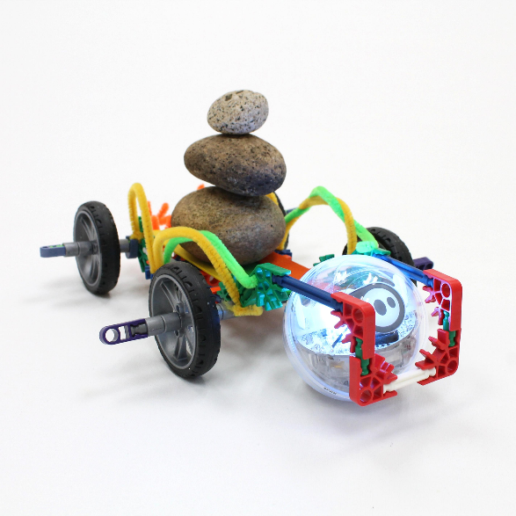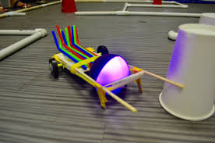

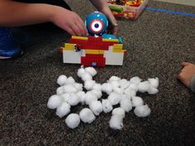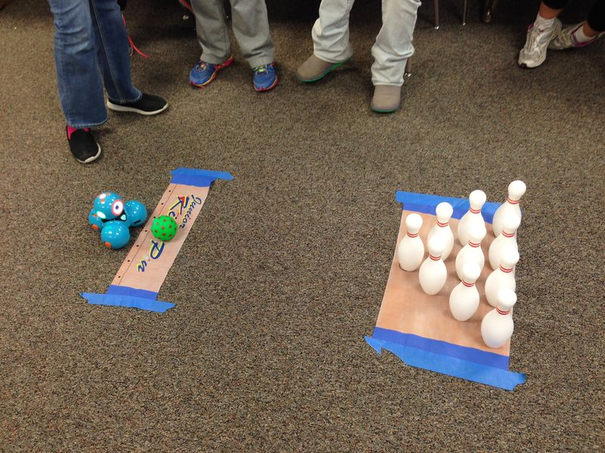

Fourth Grade
Light

S4P1. Obtain, evaluate, and communicate information about the nature of light and how
light interacts with objects.
a. Plan and carry out investigations to observe and record how light interacts with various materials to classify them as opaque, transparent, or translucent.
b. Plan and carry out investigations to describe the path light travels from a light source to a mirror and how it is reflected by the mirror using different angles.
c. Plan and carry out an investigation utilizing everyday materials to explore examples of when light is refracted.
(Clarification statement: Everyday materials could include prisms, eyeglasses, and a glass of water.)

Entry Event: Light Maze
Using the given materials, students will find a way to shine the beam of light from the starting point to the end target without going outside the lines of the maze.
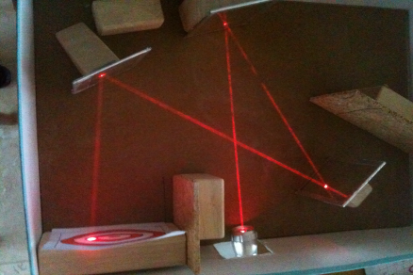
Hint: Students can use gem clips or tape to get mirrors to stand up.

Maze #1: mirrors, tape, gem clips, laser

Maze #2: mirrors, concave & convex mirrors/lenses, tape, gem clips, laser

Maze #3: mirrors, lenses, prisms, tape, gem clips, laser

Alternative Activity: Laser Maze game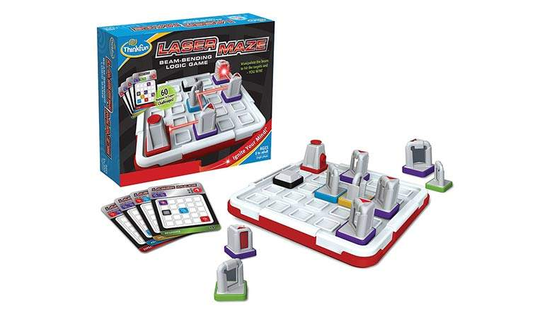

Fifth Grade
Electricity

S5P2. Obtain, evaluate, and communicate information to investigate electricity.
a. Obtain and combine information from multiple sources to explain the difference between naturally occurring electricity (static) and human-harnessed electricity.
b. Design a complete, simple electric circuit, and explain all necessary components.
c. Plan and carry out investigations on common materials to determine if they are insulators or conductors of electricity.

Entry Event – Van de Graff Generator
Students will explore the energy produced by the Van De Graff generator.

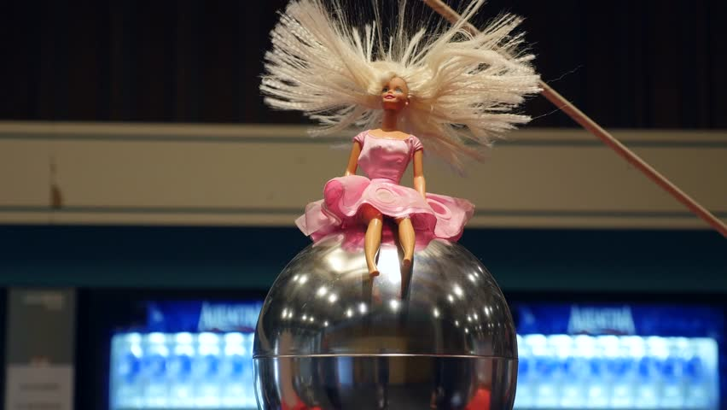

Entry Event – Makey Makey
Students will use various materials to create a circuit and determine if the materials are conductors or insulators.

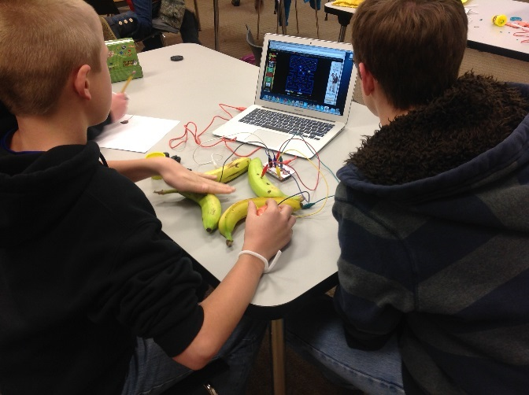
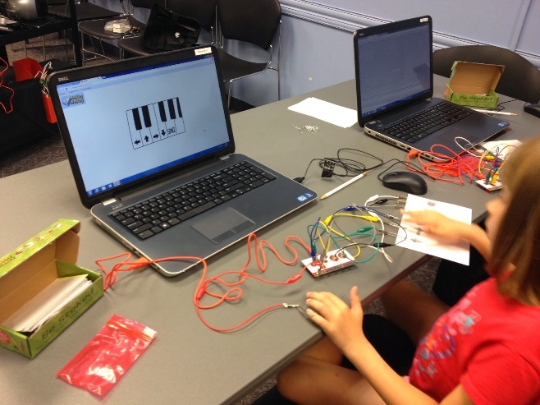

Third Grade
Heat

S3P1. Obtain, evaluate, and communicate information about the ways heat energy is
transferred and measured.
a. Ask questions to identify sources of heat energy.
Clarification statement: Examples could include sunlight, friction, and burning.)
b. Plan and carry out an investigation to gather data using thermometers to produce tables and charts that illustrate the effect of sunlight on various objects.
(Clarification statement: The use of both Fahrenheit and Celsius temperature scales is
expected.)
c. Use tools and every day materials to design and construct a device/structure that will increase/decrease the warming effects of sunlight on various materials.
(Clarification statement: Conduction, convection, and radiation are taught in upper grades.)

Entry Event – Fun with Friction
http://carrotsareorange.com/friction-experiment/
Lift a jar of rice with a chopstick.
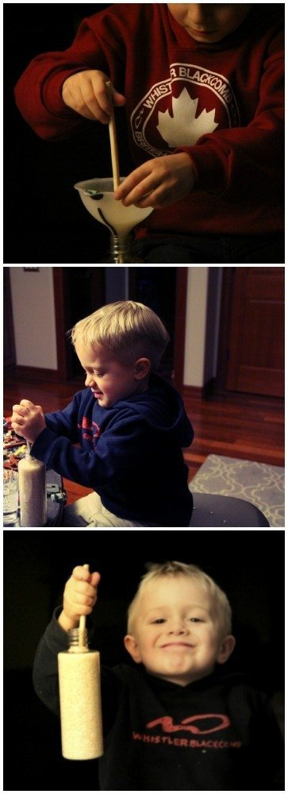
Third Grade
Heat/Conservation

S3L2. Obtain, evaluate, and communicate information about the effects of pollution (air, land, and water) and humans on the environment.
a. Ask questions to collect information and create records of sources and effects of pollution on the plants and animals.
b. Explore, research, and communicate solutions, such as conservation of resources and recycling of materials, to protect plants and animals.

Entry Event: Power Bill
Students will look at utility bills for our school and discuss the amount of energy and water that is used each month. Students will also look around the school to find other areas that can be improved. Students will work together to create a plan to conserve the resource or decrease school usage.

