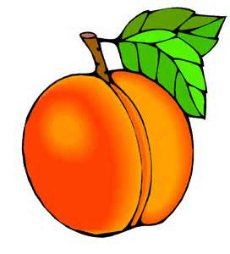
Georgia Book Awards Book Club
4th and 5th Grade Students
Come join the Georgia Book Awards Book Club. Just read 5 of the Georgia Book Award Chapter Books for this year and fill out this form. Return your form to the library by May 4th. We will have a celebration the week of May 11th for all students who return their form by May 4th. Go to the MBES Media Center Programs page for more details and a list of Georgia Books. http://www.mbesmediacenter.com/programs.html
Read 5 Georgia Book Award Chapter Books and Record your Reading Here. And, fill out the information on the back side of this page as well. Turn your completed form in by May 4th. Your parents must sign the form after you have completed it.
Title | Author
1
2
3
4
5

Student’s Name__________________________________________________
Parent Signature__________________________________________________
Date:_______________ Teacher’s Name_________________________________

Choose 3 of your favorite Georgia Books from this year and answer the following questions about those books…
Book #1
Title__________________________________________Author___________________________
Who Were the Main Characters?__________________________________________________________
What Was the Setting? (Time and Place) ______________________________________________________________________________
What did you like about this book? __________________________________________________________________________________________________________________________________________________________________________________________________________________________________________
Book #2
Title__________________________________________Author___________________________
Who Were the Main Characters?__________________________________________________________
What Was the Setting? (Time and Place) ______________________________________________________________________________
What did you like about this book? __________________________________________________________________________________________________________________________________________________________________________________________________________________________________________
Book #3
Title__________________________________________Author___________________________
Who Were the Main Characters?__________________________________________________________
What Was the Setting? (Time and Place) ______________________________________________________________________________
What did you like about this book? __________________________________________________________________________________________________________________________________________________________________________________________________________________________________________

